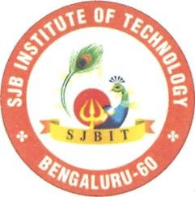
Jai Sri Gurudev ||
Sri Adichunchanagiri Shikshana Trust
' SJB Institute of Technology
Approved by AICTE-New Delhi , Recognized by UGC with 2(f) &12(B)
No. 67, BGS Health & Education City, Dr. Vishnuvardhan Road, Kengeri, Bengaluru - 560060
L + 91-80-28612445 /46 prin ipa jbi ed in + 1 8 28612651 www.sjbit.edu.in
Ref: SJBIT /ADM/2026/11 Date: 11/05/2026
CIRCULAR
All the VIII Semester students are hereby informed that Technical seminar for the Industry Internsh•R and SEC Internship Course will be conducted on 18th and 19t^ May 2026.
All students are directed to appear for the review strictly as per the schedule communicated by their respective departments. Students must present their internship progress along with all relevant supporting documents and maintain professional decorum throughout the evaluation process. Attendance for the Technical seminar is mandatory.


Failure to comply with the above instructions may affect the evaluation.


Internship Coordinator

hendra Prashanth
rincipal
Sd/-
Dr. Babu. N.V Academic Dean


Dr: Puttaraju
Academic Director

